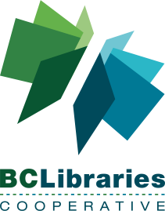

Minutes - Board Meeting April 10, 2019 at 1000 Pacific (via teleconference)

Toll-free Number: 1-866-285-3967 Conference Code: 4001 Participant PIN: 9050

Board members present: Tracey Therrien, Dr. Stan Gardner, Baharak Yousefi, Beth Davies, Dana McFarland, Dr. Diana Davidson, Mari Martin (ex officio)
Regrets: Deb Hutchison Koep
Staff present: Kevin Millsip, Sharon Herbert
- Approval of agenda
  - Additional agenda items
- Approval of February 13, 2019 minutes
- Member Participation Component
- Strategic Planning update (verbal) – Beth/Dana/Kevin
- Reports:
  - NNELS report (verbal) – Diana
  - Operational report (verbal) – Kevin/Sharon
  - Finance Report (verbal)– Tracey
    - Motion regarding Vancity Line of Credit
      - “The BCLC Board of Directors approves the Vancity $50,000 line of credit, as per the documents provided by Vancity.” (TT/SG) Unanimous.
    - Annual audit process underway
  - Governance Report (verbal) – Beth
- Public Library Partner Advisory Group update (verbal) – Kevin
- Next Meeting: Wednesday May 1, 2019 1:00pm-2:00pm to review the Strat. Plan
- Private session (Board only) – Dana
- Adjournment

